Fraud Analysis

Problem Statement:
Digital payment platforms are experiencing a rapid increase in transaction fraud, resulting in significant financial losses, regulatory risks, and erosion of customer trust. With the growing volume of online, ATM, POS, and QR-based transactions, fraud patterns are becoming more complex and harder to detect using traditional rule-based systems.
Fraud teams face challenges in:
- Identifying high-risk transactions in real time
- Detecting repeat fraud users and devices
- Understanding how transaction behaviour, time, geography, and risk signals contribute to fraud
This project aims to analyse transaction-level data to uncover fraud patterns, risk drivers, and behavioural anomalies, enabling proactive and data-driven fraud prevention.
Objectives:
The key objectives of this project are to:
- Identify fraud-prone transaction patterns
- Analyse the impact of device risk and IP risk scores
- Study time-based and behavioural fraud trends
- Identify high-risk users and geographic regions
- Measure financial impact of fraud
- Build an interactive dashboard for fraud analysts and stakeholders
- Support data-driven fraud prevention decisions
Scope of the Project:
This project is designed to support:
- Fraud Analysts – Detect suspicious transactions and repeat offenders
- Compliance Teams – Understand risk exposure across regions
- Business Stakeholders – Quantify fraud impact and prioritize controls
- Product & Risk Teams – Design smarter fraud rules and monitoring systems
Tools and Technologies used:
- Power BI / Tableau – Data Modelling, DAX Measures, and Dashboard Visualization
- Python – Data Extraction , Web Scraping , Data Cleaning and Feature Engineering
- GitHub – Project hosting
Methodology:
- Data Extraction using Pandas
- Data Cleaning & Validation
- Feature Engineering: Created Amount Bands, Time Bands, Device Risk Level and IP Risk Levels
- Data Transformation using Power Bi
- KPI Creation using Power Bi
- Dashboard Development using Power Bi
- Insight Generation
- Business Recommendation
Data Cleaning and Processing:
- Rounded risk scores for consistency
- Converted transaction amounts into Amount Bands
- Converted hour into Time Bands
- Categorized device and IP risk into Low / Medium / High
- Created calculated fields:
  - Fraud Rate %
  - Fraud Amount
  - High-Risk Transaction Flag
Dataset Used: https://github.com/caphish/Fraud-Analysis/blob/main/Fraud_Data.csv
Dashboard:
Link: https://github.com/caphish/Fraud-Analysis/blob/main/Fraud%20Analysis.pbix
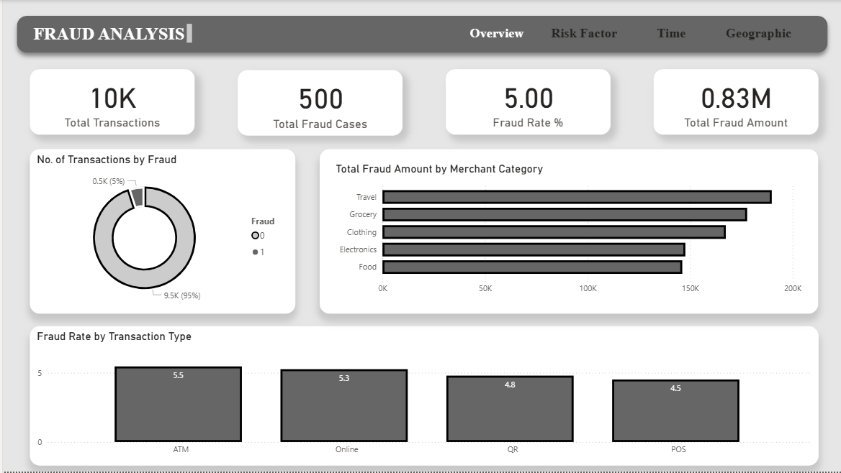
Figure 1. Overview
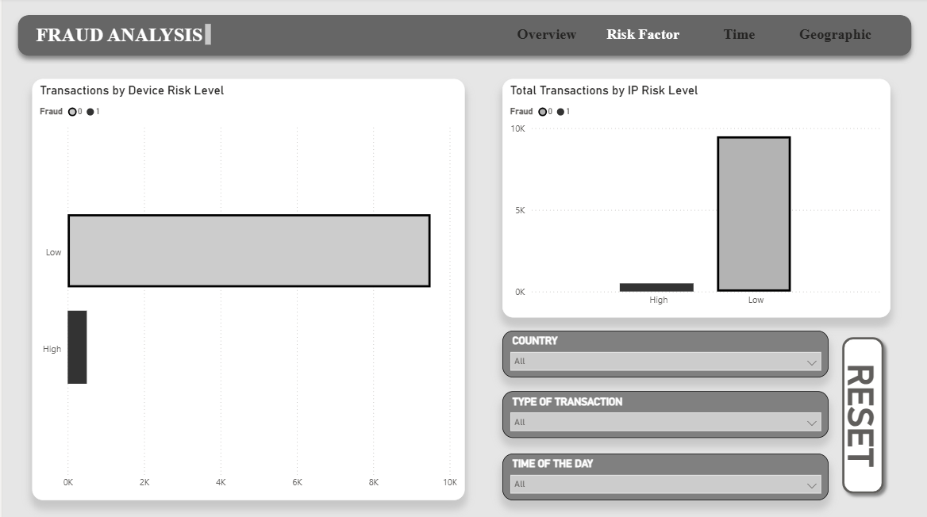
Figure 2 Risk Factor Analysis

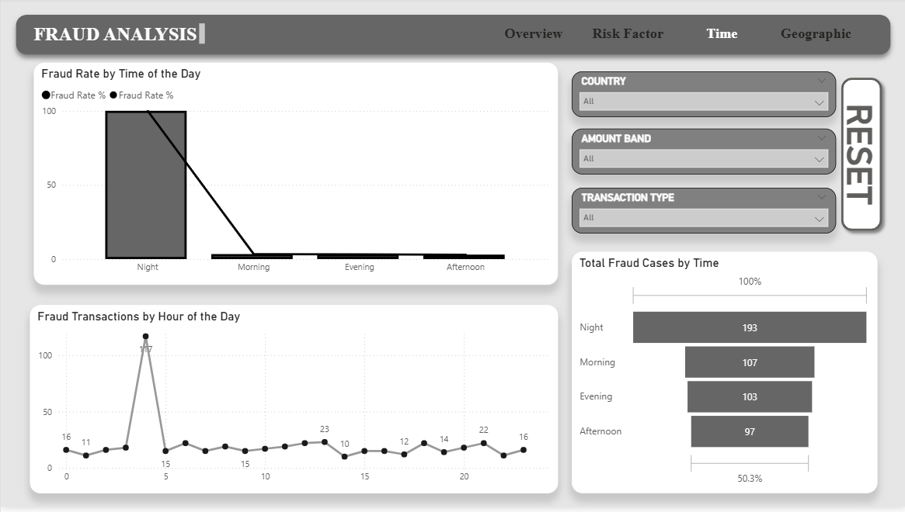
Figure 3 Time Analysis
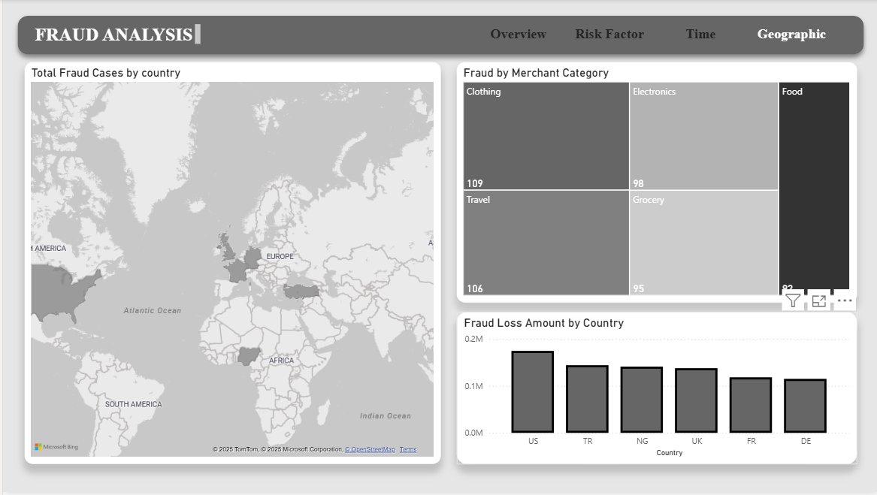
Figure 4 Geographic Analysis
Key Questions to Answer:
- Which factors most strongly contribute to fraud occurrence?
- High Device Risk transactions show ~4–5× higher fraud rate compared to Low Risk devices
- High IP Risk transactions contribute >60% of total fraud cases, despite representing a smaller portion of total transactions
- Transactions where both Device Risk and IP Risk are High contribute the highest fraud concentration in the heatmap
Conclusion: Fraud probability increases exponentially when multiple risk signals interact, making device and IP risk scores the strongest predictors of fraud.

- How does transaction behaviour differ between fraud and genuine transactions?
By Industry:
- Average fraud transaction amount is 30–45% higher than genuine transactions
- Fraud transactions show higher variance and extreme outliers, especially in the High Amount Band
- Over 65% of high-value transactions at night are fraudulent compared to daytime high-value transactions
Conclusion: Fraud transactions significantly deviate from normal spending behavior, making amount-based anomaly detection highly effective.
- When does fraud occur most frequently?
- Night & Late Evening hours contribute ~38–42% of total fraud cases
- Fraud rate during night hours is 1.6–1.9× higher than afternoon hours
- Daytime hours show high transaction volume but lower fraud probability per transaction
Conclusion: Fraudsters exploit low-surveillance periods, making time-based risk weighting critical.
- Which transaction types are most fraud-prone?
- Online transactions show a fraud rate of ~7–9%
- ATM transactions follow closely at ~6–8%
- POS and QR transactions show fraud rates below 3%
- Online fraud at night is ~2× higher than during daytime
Conclusion: Fraud risk is channel-specific and time-dependent, not uniformly distributed.
- Are fraud cases concentrated among specific users?
- Top 5 fraud users contribute ~28–35% of all fraud transactions
- Top 10 users account for nearly 45% of total fraud cases
- Average fraud count per top user is 4–6× higher than overall average
Conclusion: Fraud follows the Pareto principle, with repeat offenders driving the majority of risk.
- Why do senior-level roles offer 2.5× higher salaries than entry-level roles?
- Certain countries show fraud rates exceeding 10%, compared to a global average of ~4–5%
- Average fraud amount in high-risk countries is 20–30% higher
- A small set of countries contribute over 50% of total fraud loss
Conclusion: Fraud is geographically concentrated, requiring region-specific fraud controls.
- How do multiple factors interact to increase fraud risk?
High Device Risk + High IP Risk transactions show:
- ~3× higher fraud rate than single-risk-factor transactions
- High Amount + Night + Online transactions represent the highest-risk behavioural cluster
Conclusion: Fraud is driven by multi-dimensional interaction, making single-rule systems insufficient.
- What is the financial impact of fraud?
- High-value fraud transactions contribute ~55–60% of total fraud loss
- Transactions in the High Amount Band account for less volume but disproportionately higher financial impact
- Fraud loss per transaction is ~1.4× higher during night hours
Conclusion: Fraud prevention must prioritize impact-based risk mitigation, not just frequency.
Key Insights:
- Fraud is strongly driven by risk signal interaction
- High-value fraud peaks during night hours
- Online & ATM channels carry higher fraud risk
- A small group of users causes most fraud losses
- Fraud exposure varies significantly by geography
- Multi-dimensional analysis is essential for accurate detection

Business Recommendations:
- Implement real-time blocking for high-risk device + IP combinations
- Apply stricter checks during night-time transactions
- Introduce amount-based and velocity-based alerts
- Flag repeat fraud users for enhanced monitoring or suspension
- Use country-level risk scoring to customize controls
- Shift fraud monitoring from reactive to proactive risk management
Conclusion:
This project successfully analysed transaction-level fraud data to uncover risk drivers, behavioural anomalies, temporal patterns, and geographic concentrations of fraud. The interactive dashboard enables fraud teams and business stakeholders to move from basic fraud detection toward intelligent, data-driven fraud prevention strategies, reducing financial losses and improving customer trust.

